1. This tool tip is not in the SPM standard format -

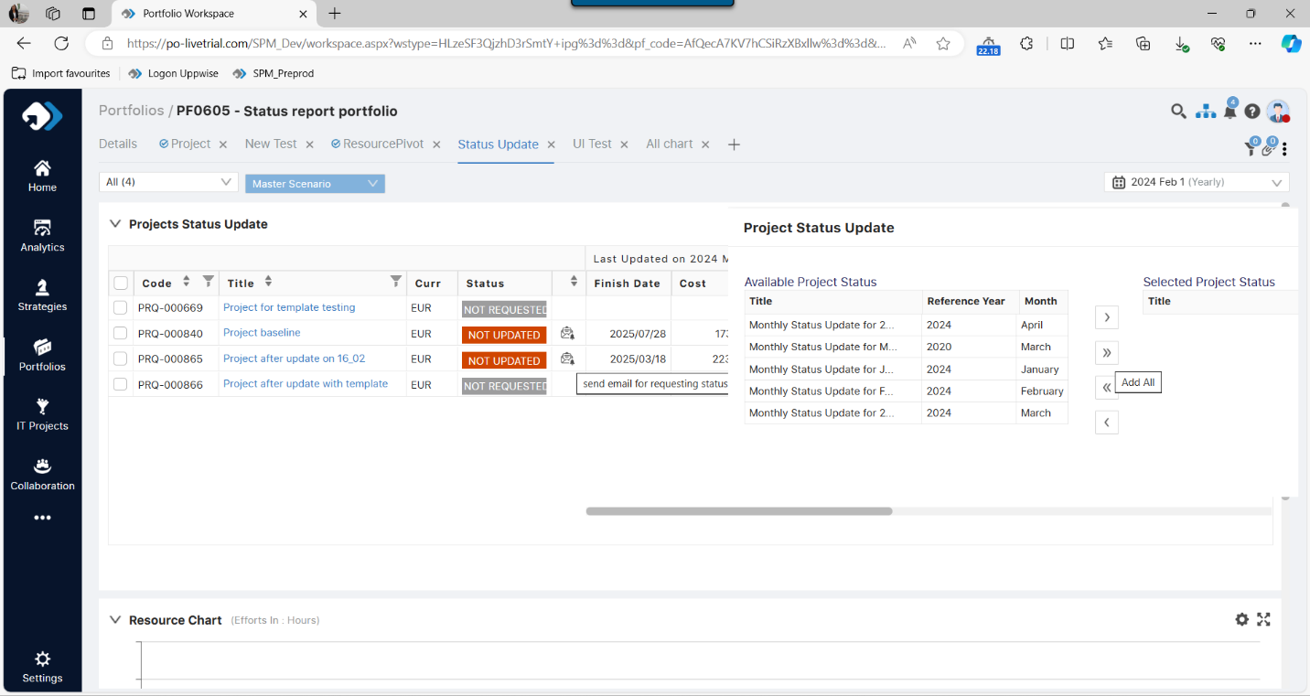

1. This alignment is disturbed after data is more than 3 rows - Done

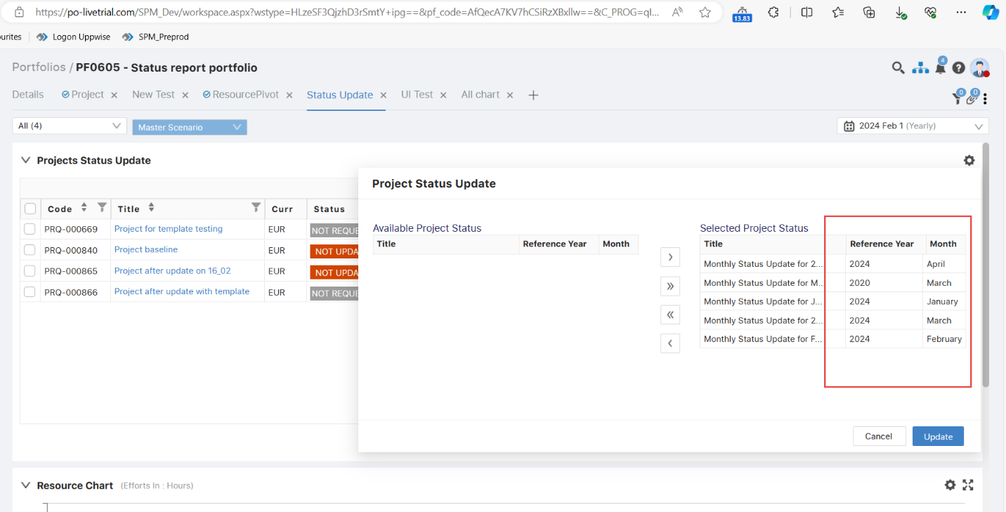

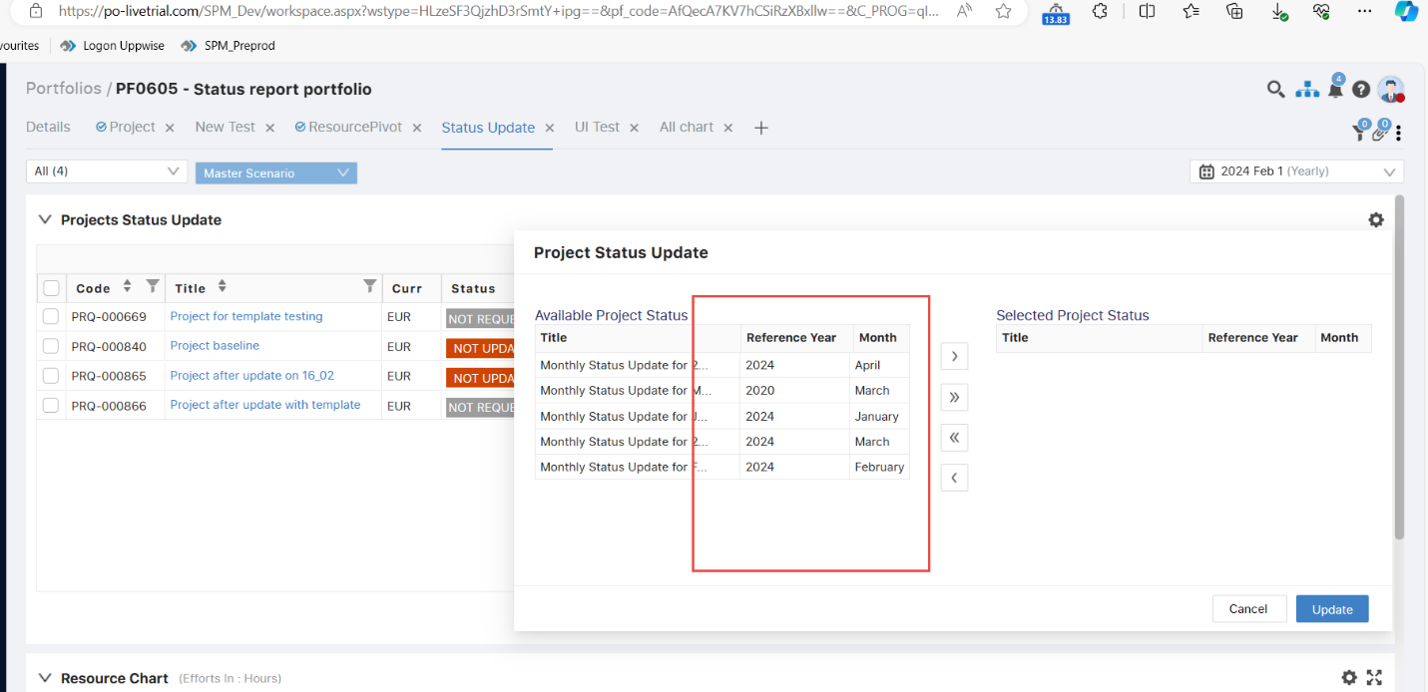

1. As per the SPM standard format we can open this popup on the center of the page -

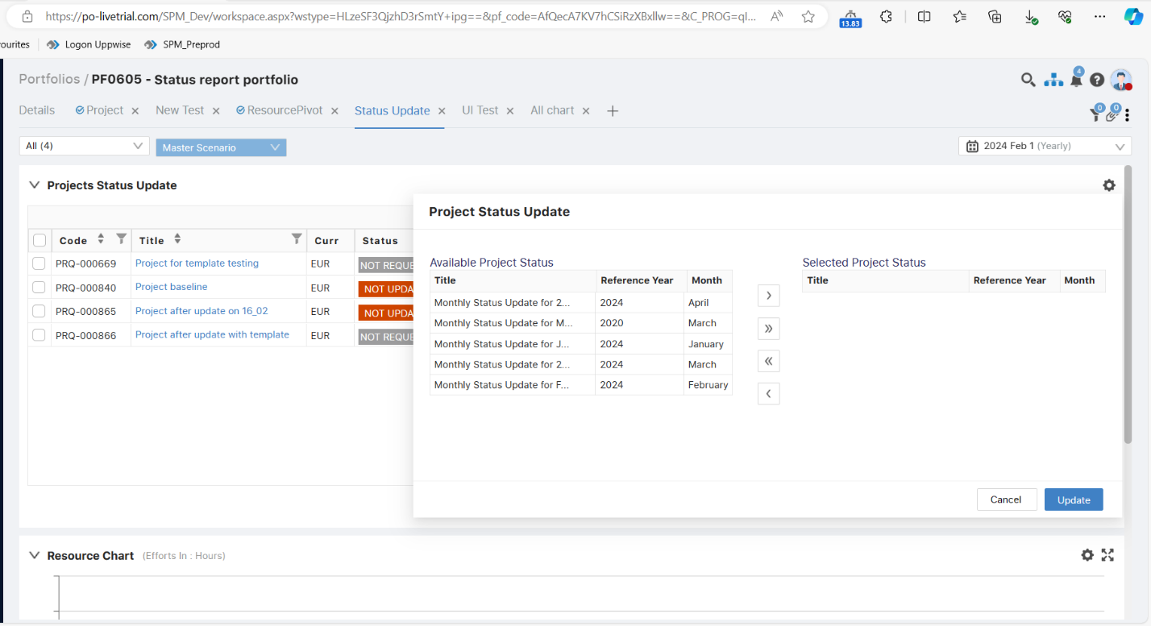

1. This Zoom icon should be dynamic on the card on the comment-

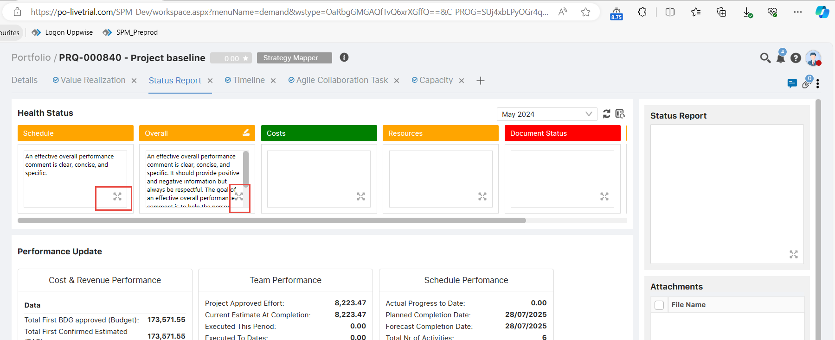

1. There is text under the attachment “Drag document for attachment” but for the attachment we have to the folder > if we wrote this text- after click on the placeholder are redirect to the My files. Done

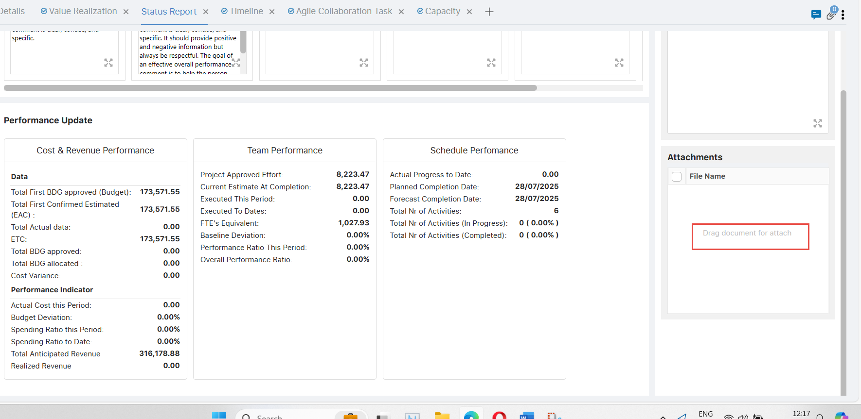

1. If data is not synced > status report page does not appear correct -

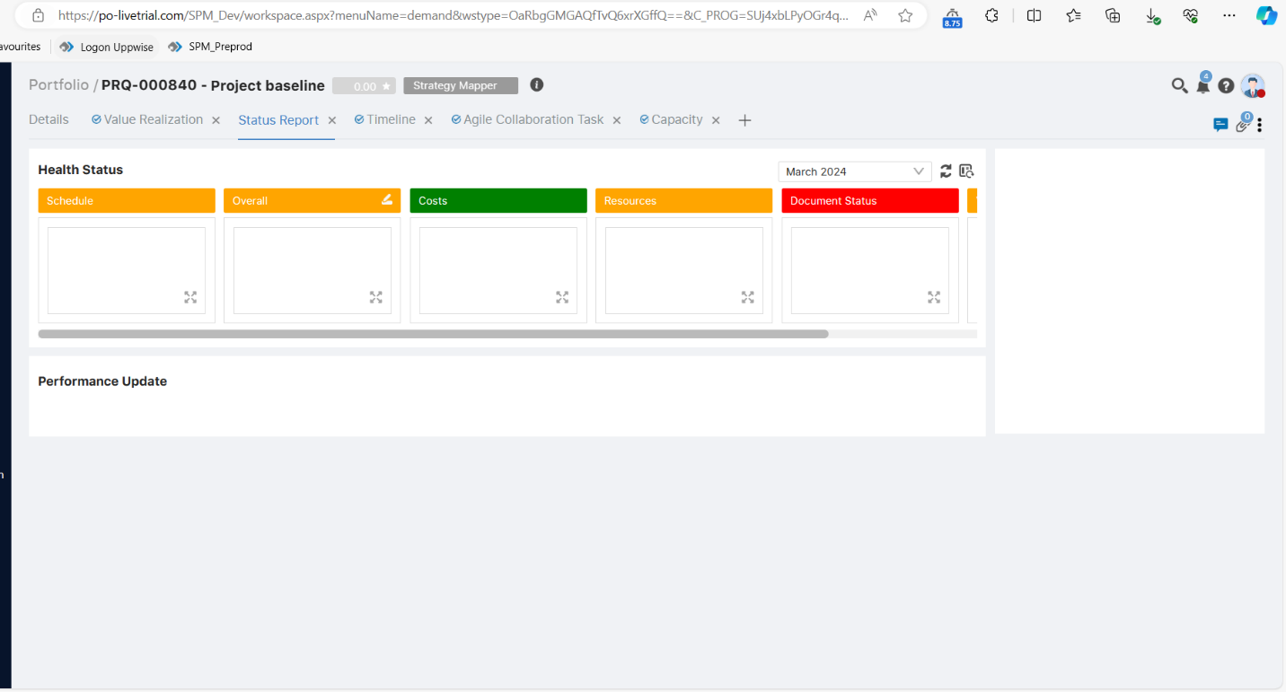

1. If file name is big then full file name does not appear and also there is not tool tip appeared - Done

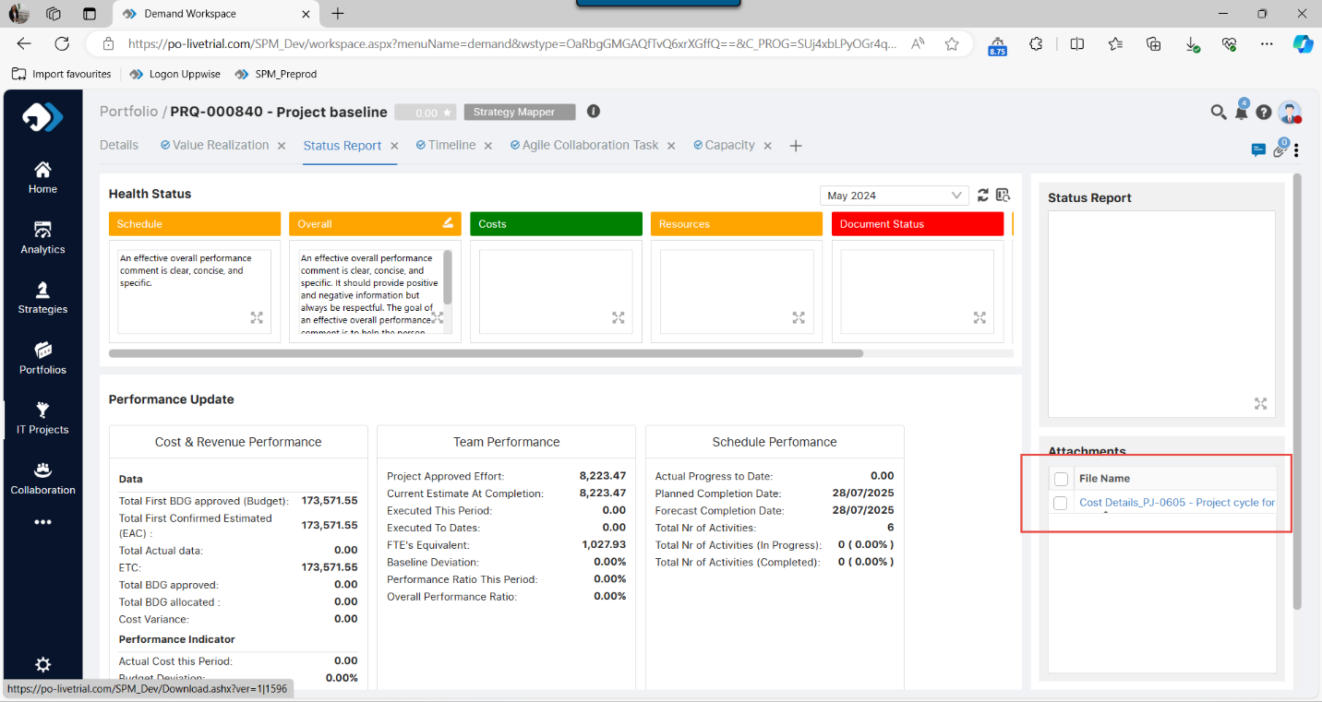

1. If whole page is in Read only mode, then Attachment section should appear in RO mode > because if we try to add the attachment it does not give any message or something info that we are not able to add the attachment -

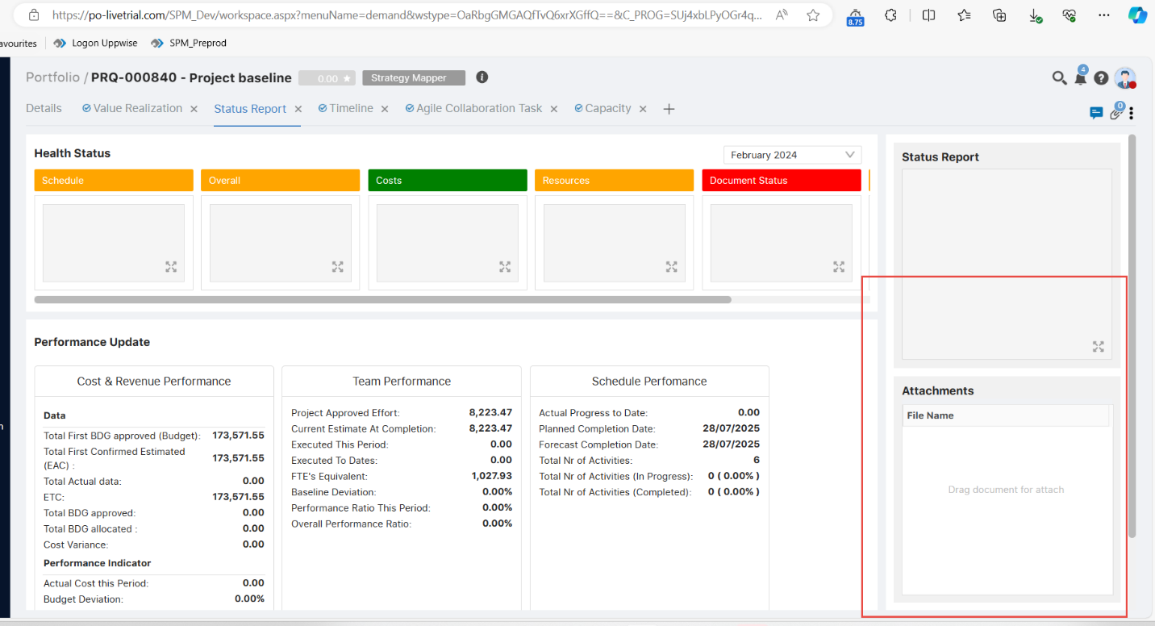

1. This Cancel button alignment is not correct - Done

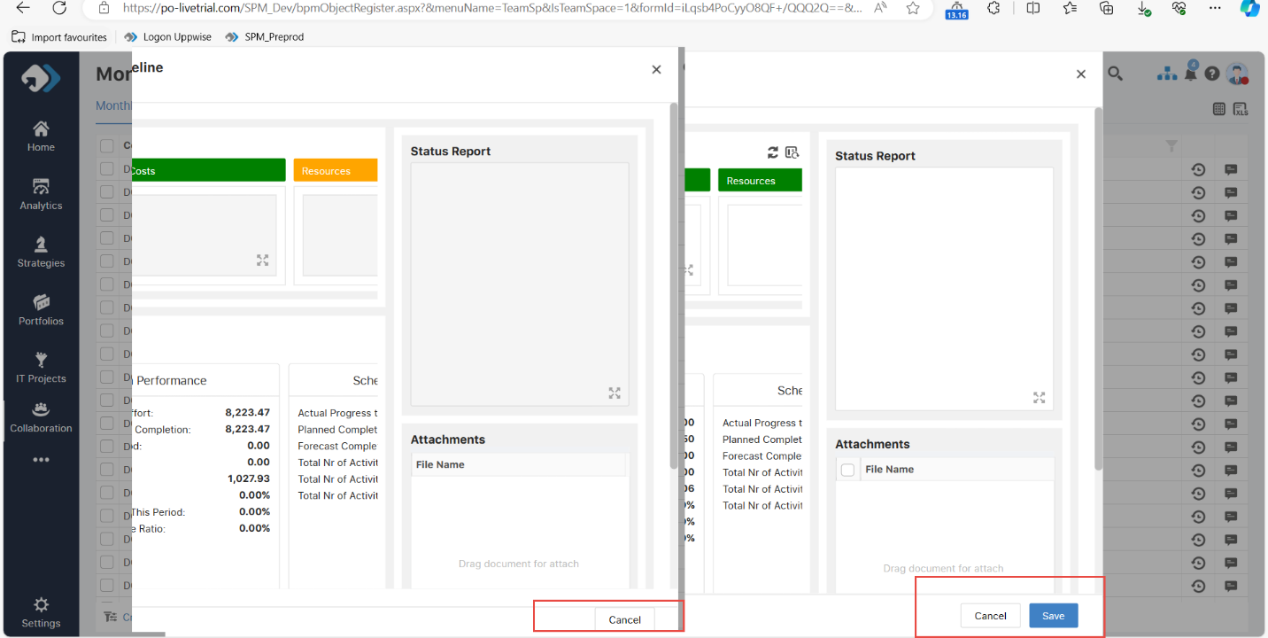

1. Not able to test with the project, it gives some error while creating the status report -

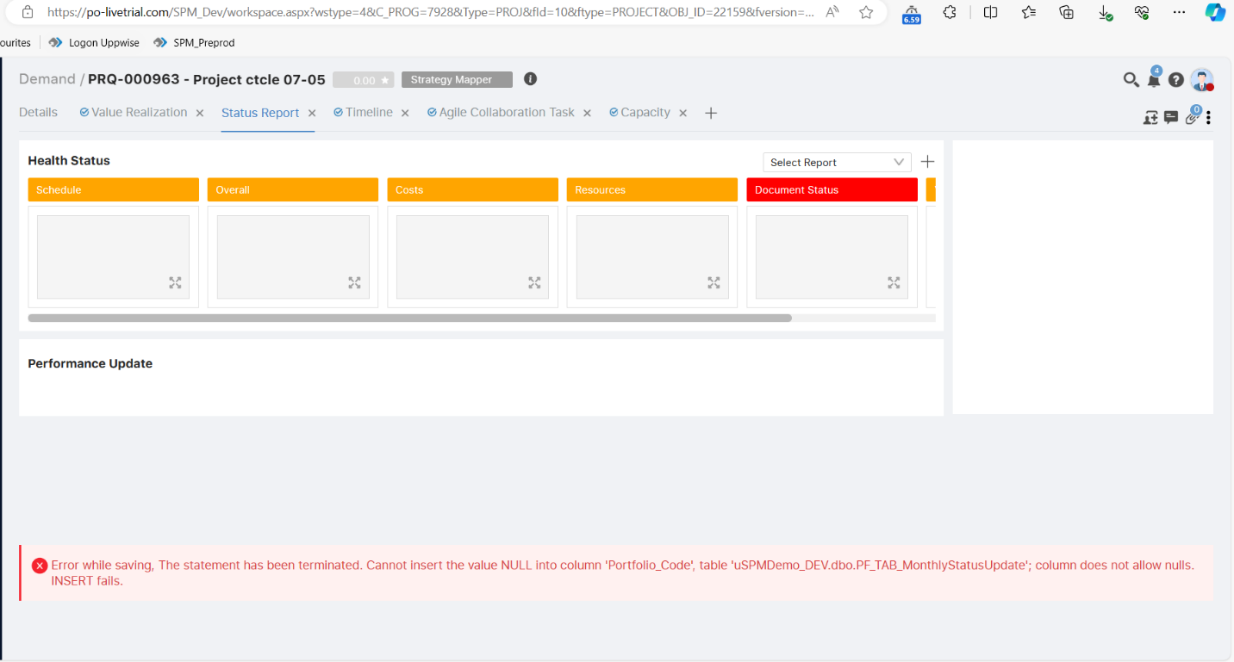

1. These flags are central aligned but, in the SPM, standard flags appeared in left aligned -

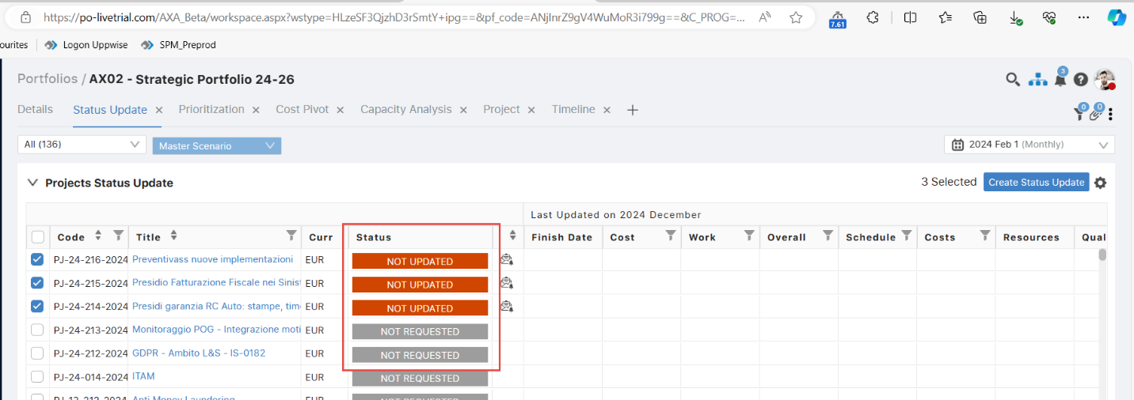

1. This sorting button is no user on the email column -

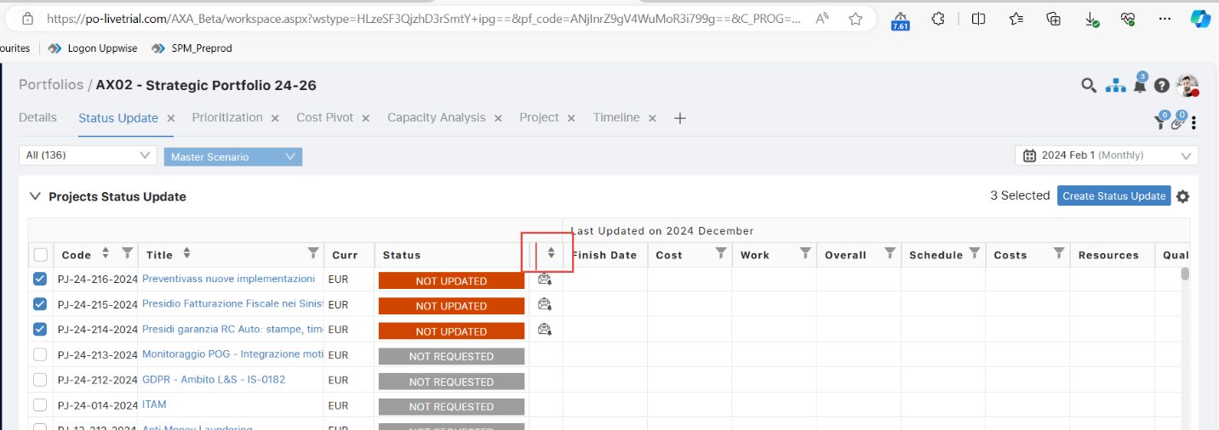

1. According to the feature document > After zoom the header color should be appeared of that key -

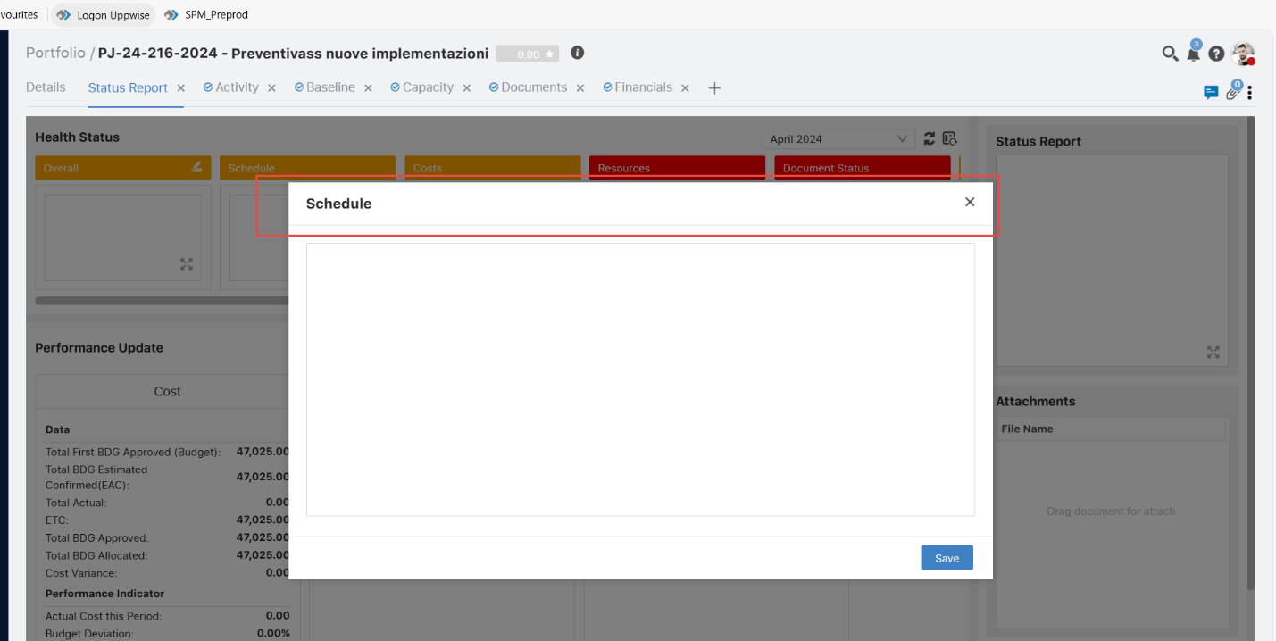

1. One liner should be changed -

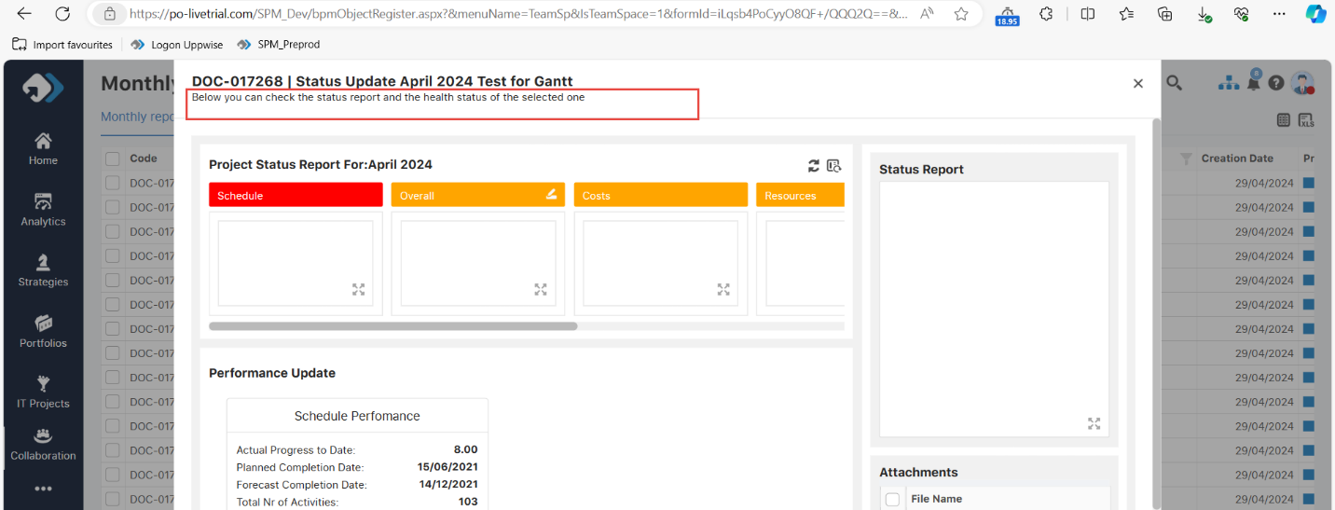

1. These color options are not correct for the overall color - Done

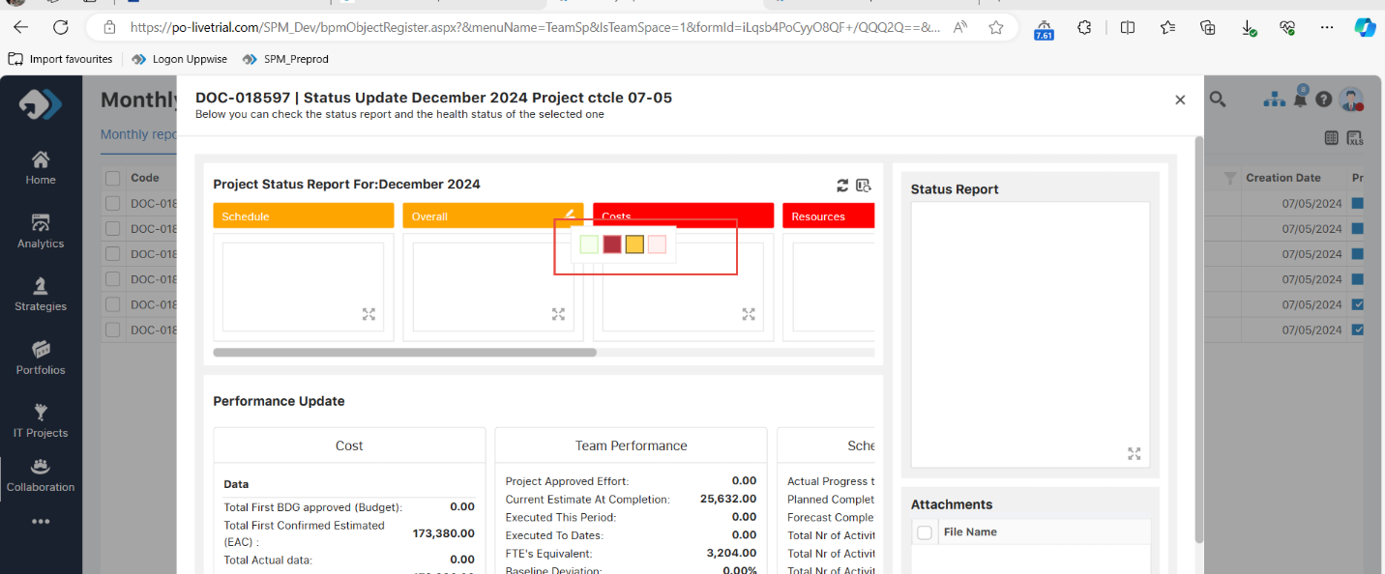

1. This button needs to be the same as POX. In the POX this button name is Send Status update - Done

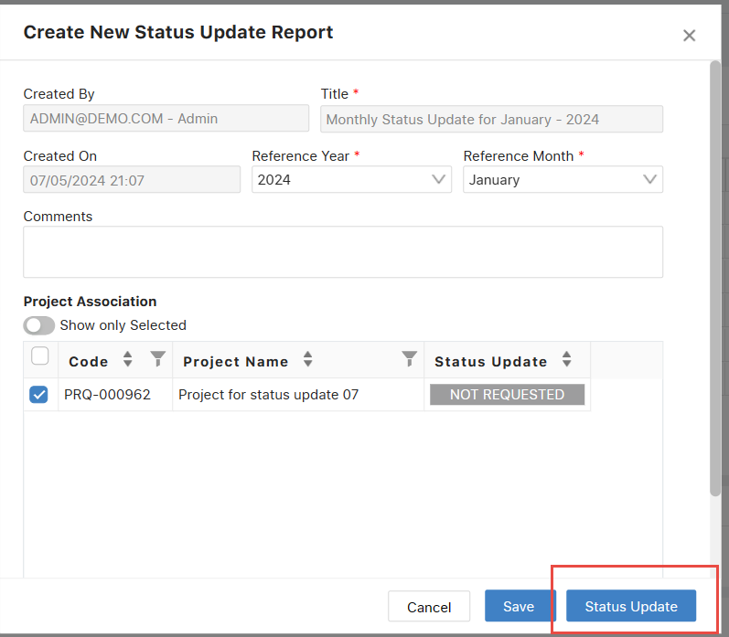

1. Design needs to be correct for this popup -

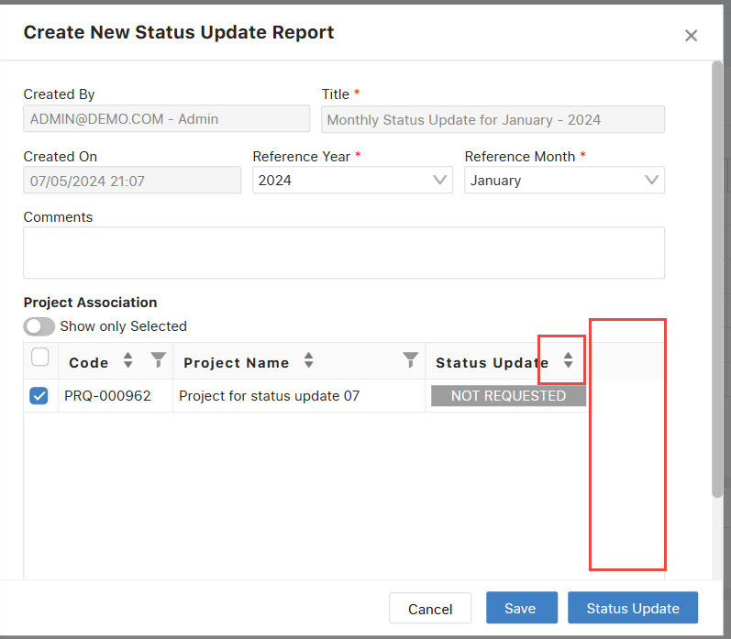

1. There is a gap between scroll bar and page -

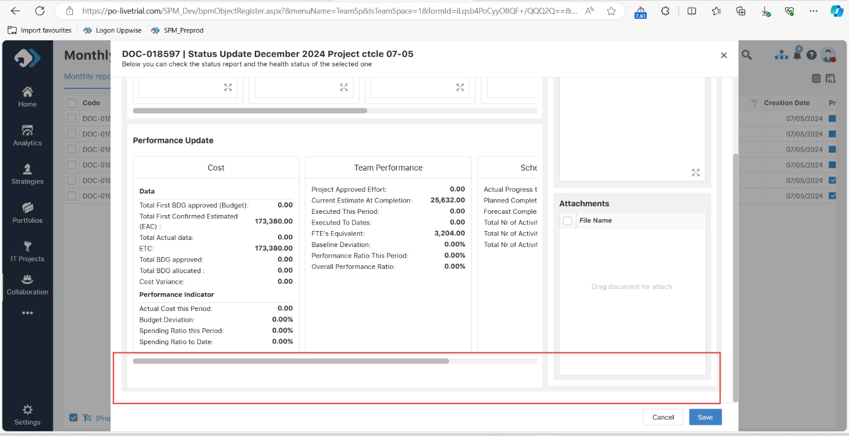

1. Header should be same on the Team space and workspace both -

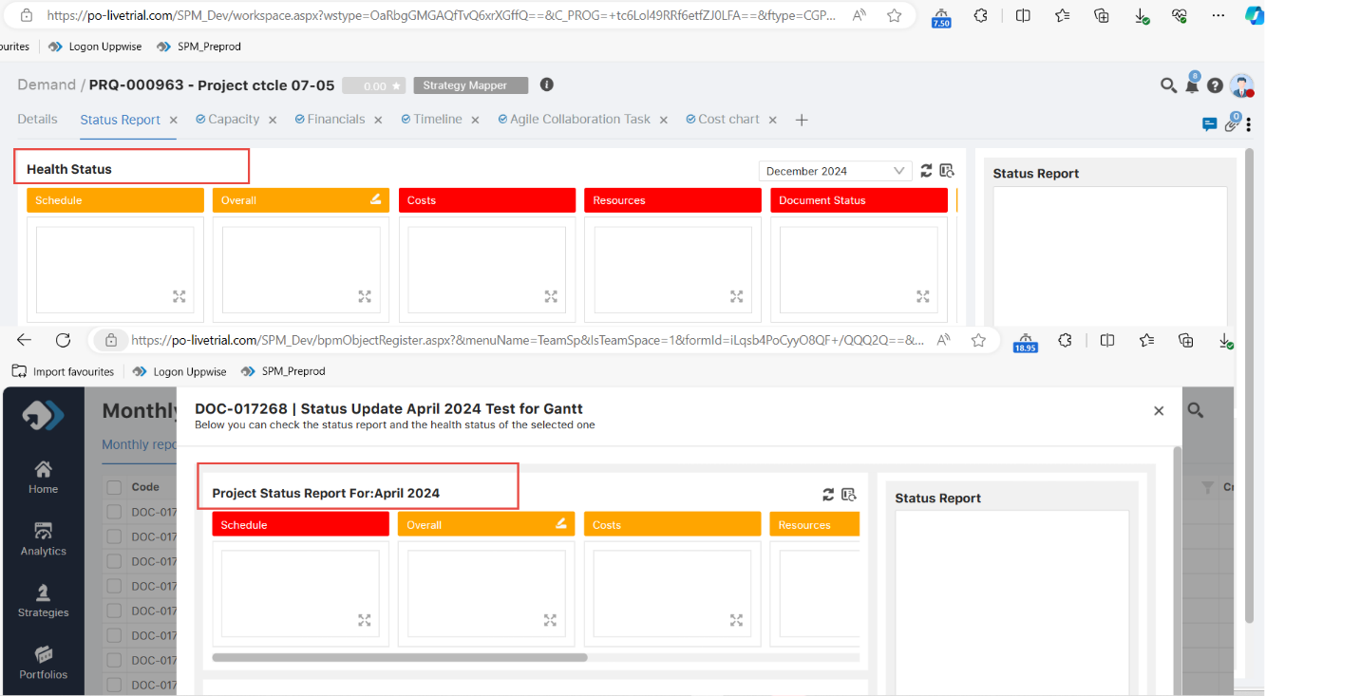

1. Email service is working fine – Reminder mail is going to the users who is assigned for the mail -

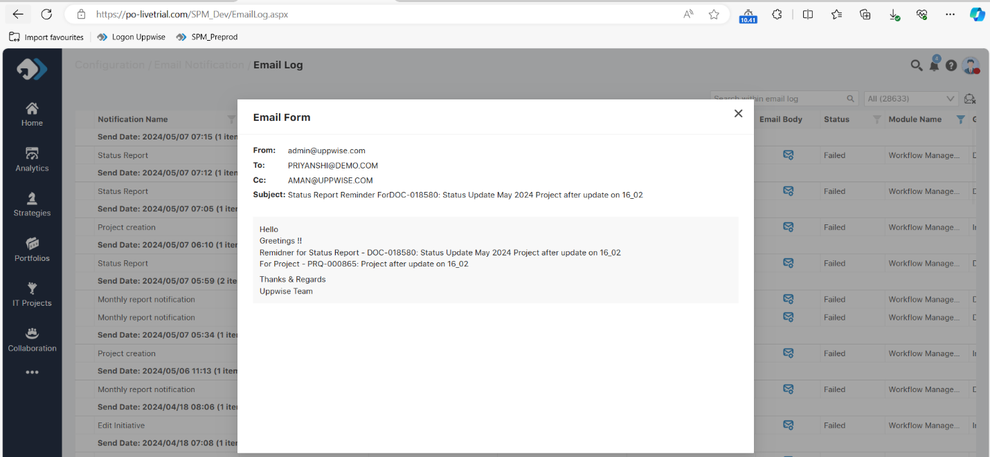

1. New created status report does not appear under the gear icon -

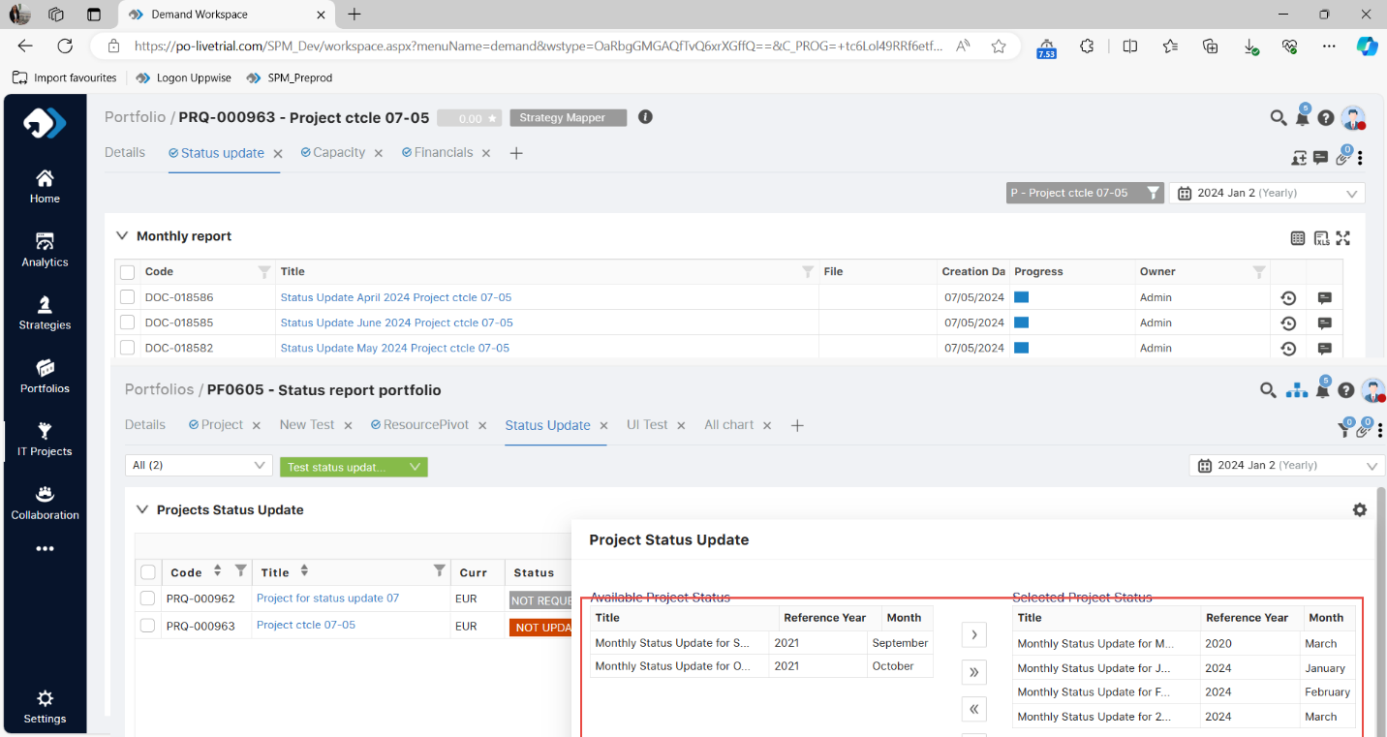

1. Without sync the data > we are not able to release the status report-
2. This scroll bar should be adjusted according to the data -

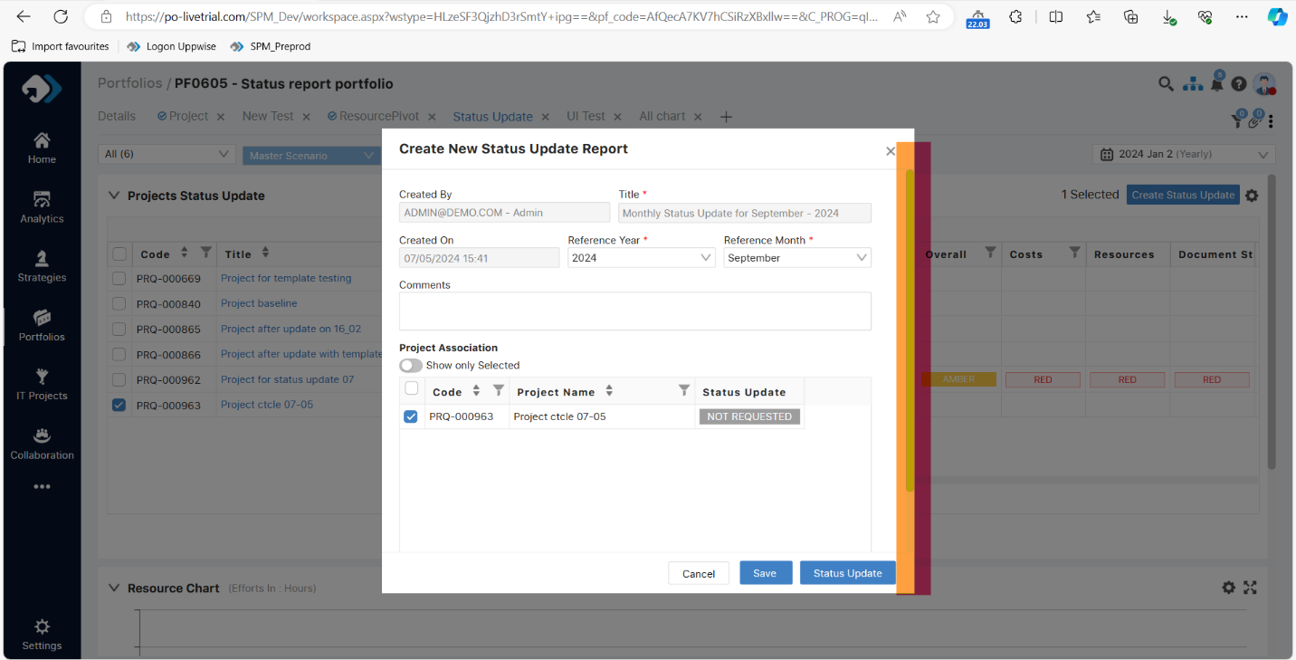

1. In SPM we are not using any Snapshot functionality please correct the message -

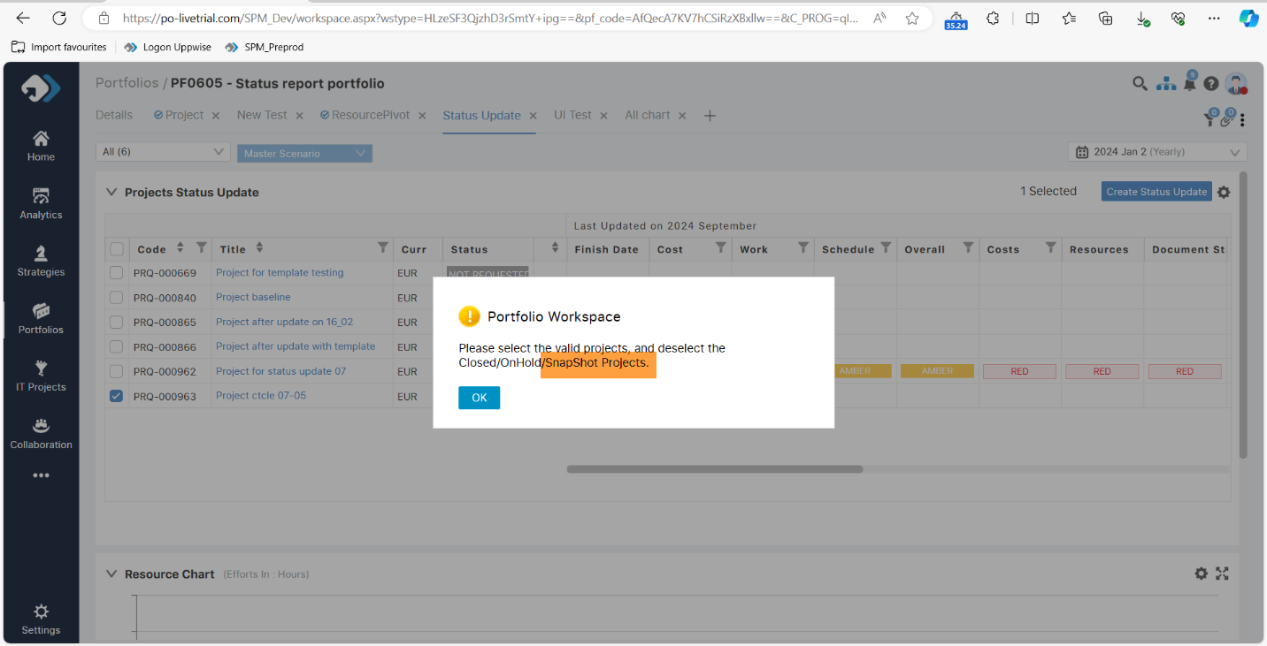

1. Health card color is impacting > while changing syncing the data of the current month and previous month card color is also changed.